ICP2-SHASHANK ARVA-700756617

1. Write a program that takes two strings from the user: first_name, last_name. Pass these variables to fullname function that should return the (full name).

Write function named “string_alternative” that returns every other char in the full_name string.

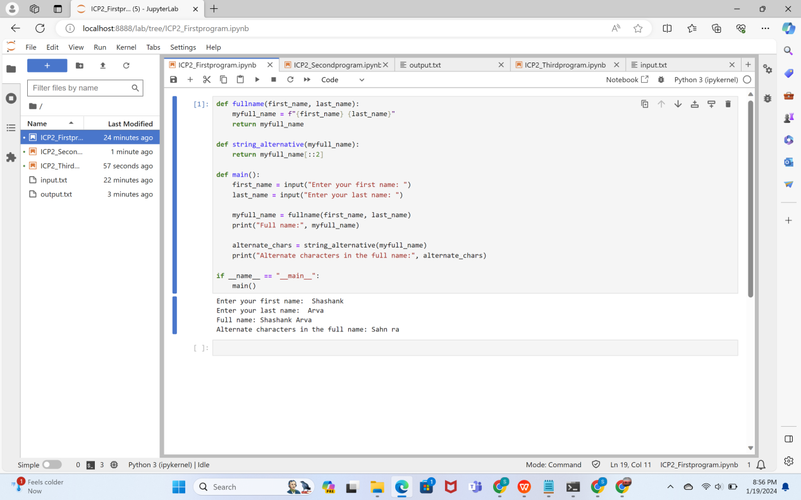

1. Write a python program to find the wordcount in a file (input.txt) for each line and then print the output. o Finally store the output in output.txt file.

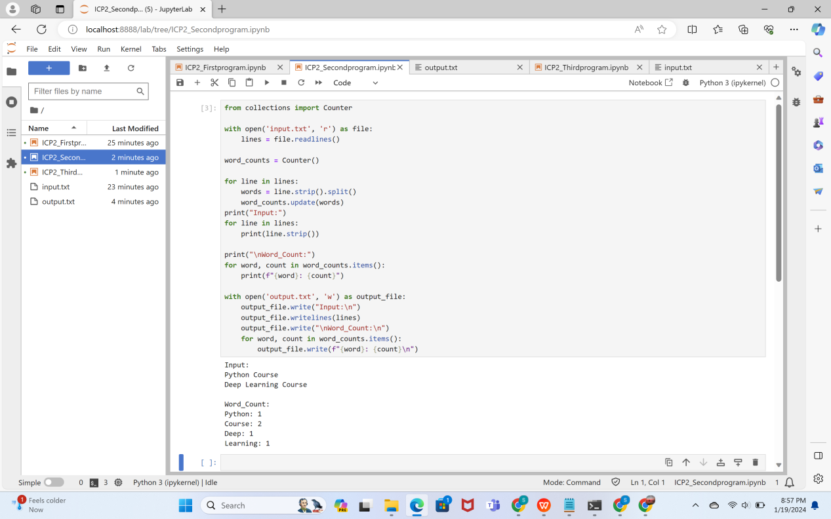

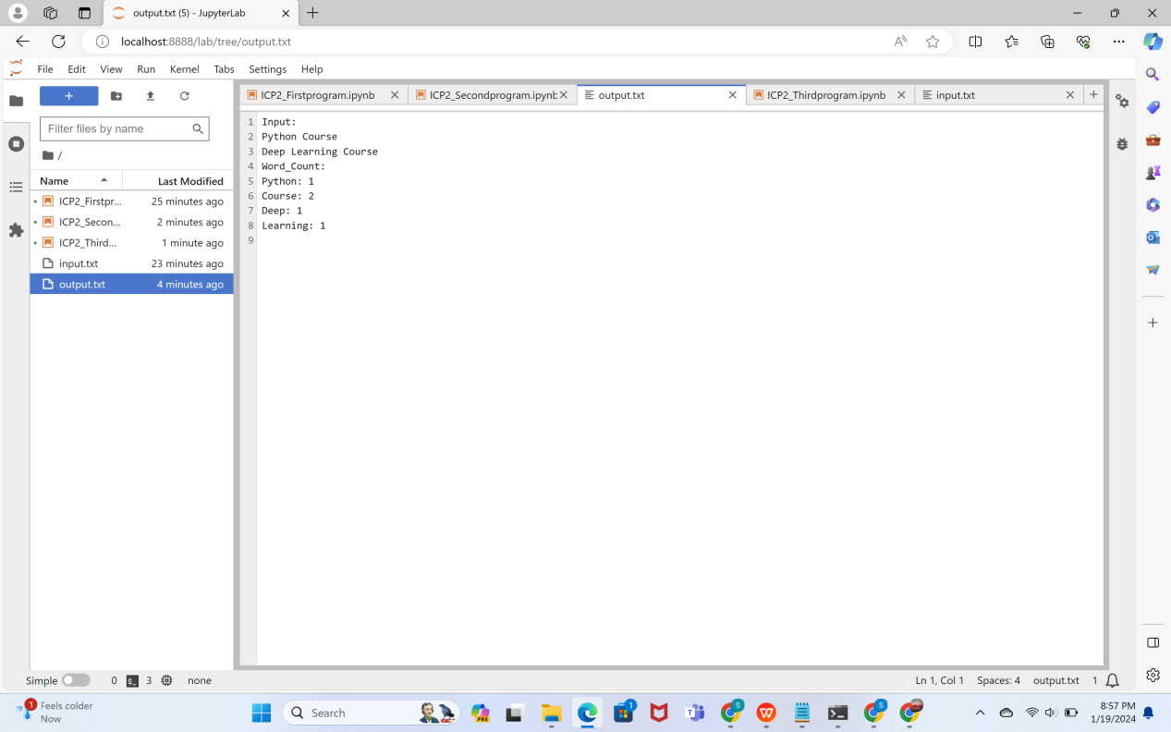

1. Write a program, which reads heights (inches.) of customers into a list and convert these

heights to centimeters in a separate list using:

1) Nested Interactive loop.

2) List comprehensions

